Part 1: Olympic Track & Field Visualizations
1. Explore the Dataset
Dataset Overview
- Total Records: 2,161
- Columns: 14
- Time Period: 1896–2016 (Olympic medal results)
- Main Columns:
Name, Year, Event, Event2, Gender, Location, Medal,
Nationality, Result, Format, SmallerIsBetter, Distance, performance, olympic_record
The dataset includes both track (timed) and field (distance/points) events.
performance already gives standardized numeric values (seconds or meters).
Data Quality Findings:
Missing / Null Data
Column | Missing Count | Explanation
Name | 209 | Missing for all relay team events (e.g., 4x100m, 4x400m). Represents team entries rather than individuals.
Distance | 692 | Blank for field and multi-events (e.g., Long Jump, Decathlon) since distance isn’t applicable.
Other Columns | 0 | All other fields are fully complete.
Total Null Records: Almost 41% of dataset has at least one missing value (mostly in Name or Distance).
Event Naming Issues:
- Trailing Spaces: All Event2 entries contain trailing spaces.
- Redundant Gender: Gender appears in both Event (e.g., “100M Men”) and Gender column.
- Inconsistent Case: Examples like “4X100M Relay” vs “20Km Race Walk.”
- Missing Events: Some women’s events (100m hurdles, heptathlon) are missing.
Units and Result Formatting:
- Result mixes formats (seconds, minutes, hours, meters).
- Format = "Meters" incorrectly used for Decathlon (points).
- Distance is inconsistently populated, only for races.
- SmallerIsBetter is consistently correct (Y for timed, N for distance).

Gender Labeling:
- Uses M/W, while Event says “Men/Women.”
- Only two valid values (M, W) , consistent but unclear.
Text and Data Errors:
- Encoding Issues: 75 athlete names corrupted (e.g., “Emil Z√É¬ÅTOPEK” to “Emil Zátopek”).
- Wrong Country: Mo Farah 2016 marked “USA” instead of “GBR.”
- Olympic Record Flag: Multiple medalists in one event marked as record-holders (“yes”) instead of just the top result.
Working:
In Excel, I created a few calculated columns to prepare data for visualization ,specifically Lag Behind Best, Speed, and Olympic Performance All Time.
- Speed: was computed as Distance ÷ Performance, converting results into meters per second.
- Olympic Performance All Time: used =IF($K2="Y", MINIFS($M:$M, $C:$C, $C2), MAXIFS($M:$M, $C:$C, $C2)),
which selects the fastest (minimum) or best (maximum) performance for each event.
- Lag Behind Best: was derived by subtracting each athlete’s performance from the Olympic Performance All Time best record, showing how far behind they were compared to the Olympic leader.
In Tableau, I added additional calculated fields to enhance readability, including:
- Country Full Name: derived from the abbreviated nationality column.
- Gender and Medal Full Name: replaced abbreviations (M/F, G/S/B) with full labels (Male/Female, Gold/Silver/Bronze).
These fields improved clarity and consistency across all visualizations.

2. Study Existing Visualizations
Overview: Why These Visuals Matter
Track & Field (especially the 100m sprint) has inspired some of the most iconic data visualizations by The New York Times (NYT) and Kaggle.

They turn raw race times into visual stories showing how athletes like Usain Bolt transformed sprinting.

Goals:

How professionals visualize performance and records.

Similar storytelling and clarity to our dataset (OlympicTrackAndFieldResultsEnhanced.csv).

NYT’s “One Race, Every Medalist Ever” (2012)
A legendary NYT visualization imagined every Olympic 100m medalist running together on an 88-lane track,

each lane a medalist, with Usain Bolt finishing first and others shown where they’d be when he finishes.

Shows:

How modern athletes outperform past champions.

A human-scale comparison of speed differences.

Emotional storytelling through physical distance instead of charts.

Design Lesson: Turning time differences into visible distance makes performance gaps instantly clear.

NYT’s 3D / Side-View Versions
Later versions added perspective and real track imagery, with captions and storytelling focus.

They stood out for combining realism, narrative, and data accuracy.

Kaggle & Analytical Visuals
Kaggle focuses on data-driven visuals that analyze trends:

A. Record Progression Charts (Line charts) – show sprint times improving almost20% since 1900s.

B. Athlete Attributes (Scatterplots) – explore links between age, BMI, and performance.

C. Medal & Geography Charts (Bars/Maps) – reveal dominance by the U.S. and Jamaica.

D. Athlete Comparisons (Dashboards) – compare Bolt vs. Gatlin or different Olympics.

E. Event Timelines – highlight record jumps visually.

Modern Example: “Photo-Finish” (Paris 2024)
A 2024 World Athletics graphic aligned all 100m finalists at the finish line, showing a 0.03s gap between gold and silver.

Lesson: Even milliseconds can tell a story when visualized effectively.

3. Create Required Visualizations
Task 1: Scatterplot for a Single Event
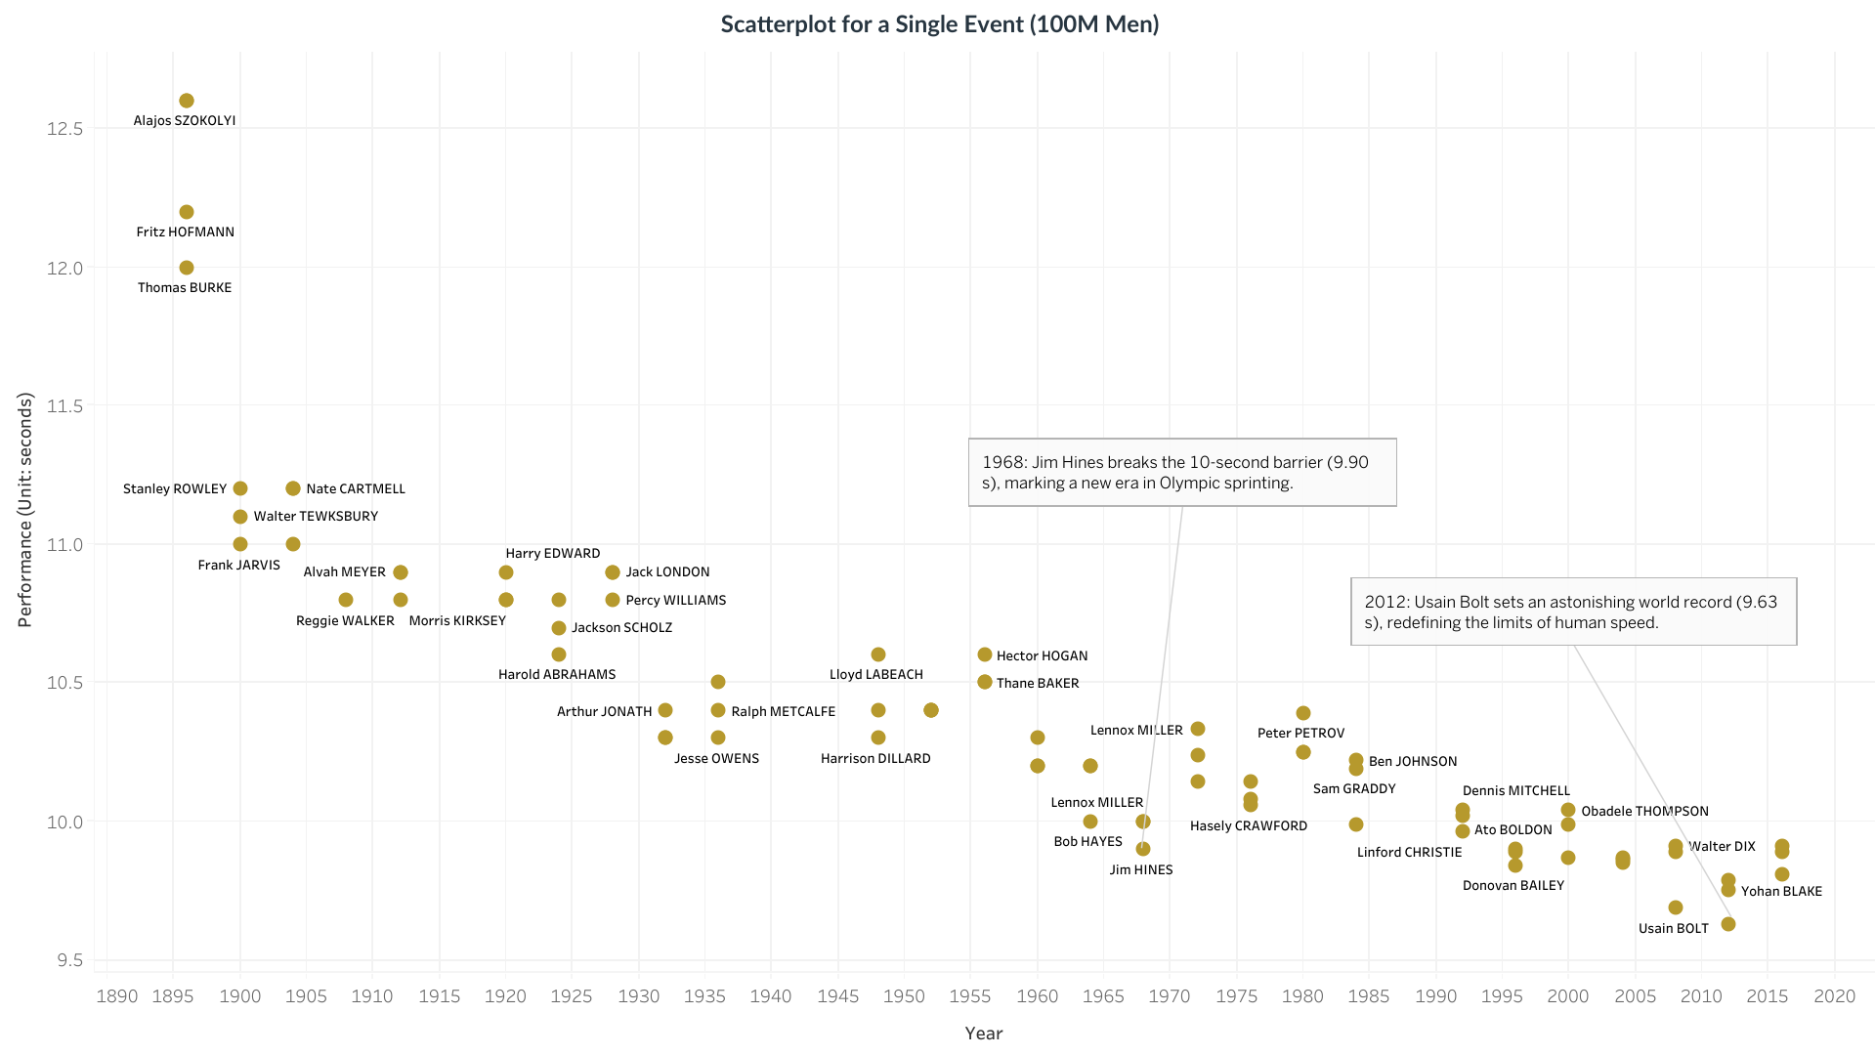
Interpretation:
- Men’s 100 m sprint performance improved dramatically from almost12.5 s in 1896 to under 9.7 s by 2012, marking a almost23% speed gain over a century.
- Jim Hines’ 1968 record (9.90 s) broke the 10-second barrier, redefining sprinting standards, while Usain Bolt’s 2012 record (9.63 s) remains the benchmark of human speed.
- The average winning time has fallen by roughly 0.1 s per Olympic decade, showing continuous advancements in training, biomechanics, and track technology.
Task 2: Scatterplot with Complete Dataset
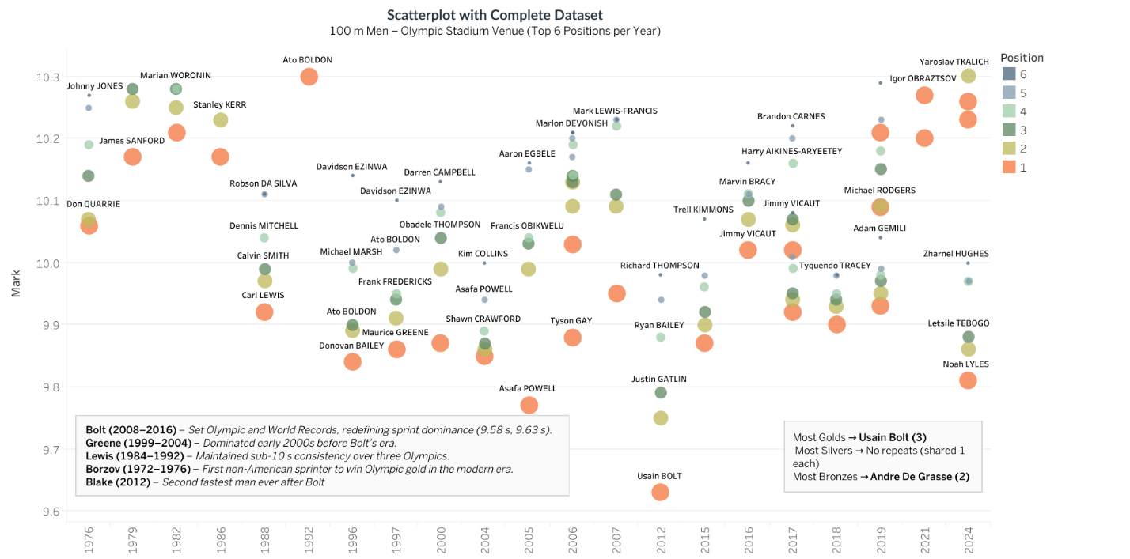
Insights – 100 m Men (Olympic Stadium, Top 6 Positions per Year)
- From 1976 to 2024, the men’s 100 m Olympic performances improved by nearly 0.4 seconds, dropping from almost 10.3 s to around 9.9 s or faster.
- Usain Bolt’s 2008–2016 runs (9.58 s–9.63 s) remain the fastest ever, about 0.2 s quicker than other finalists, equivalent to a 1.5 m lead.
- Maurice Greene (1999–2004) maintained an average of 9.87 s, while Carl Lewis (1984–1992) consistently ran around 10.0 s, narrowing the Olympic average gap by 0.07 s.
- In recent finals, the top 6 finishers are separated by only 0.05–0.08 s, showing unprecedented competitiveness and the impact of global sprinting progress.
Task 3: NYT-Style Visualization
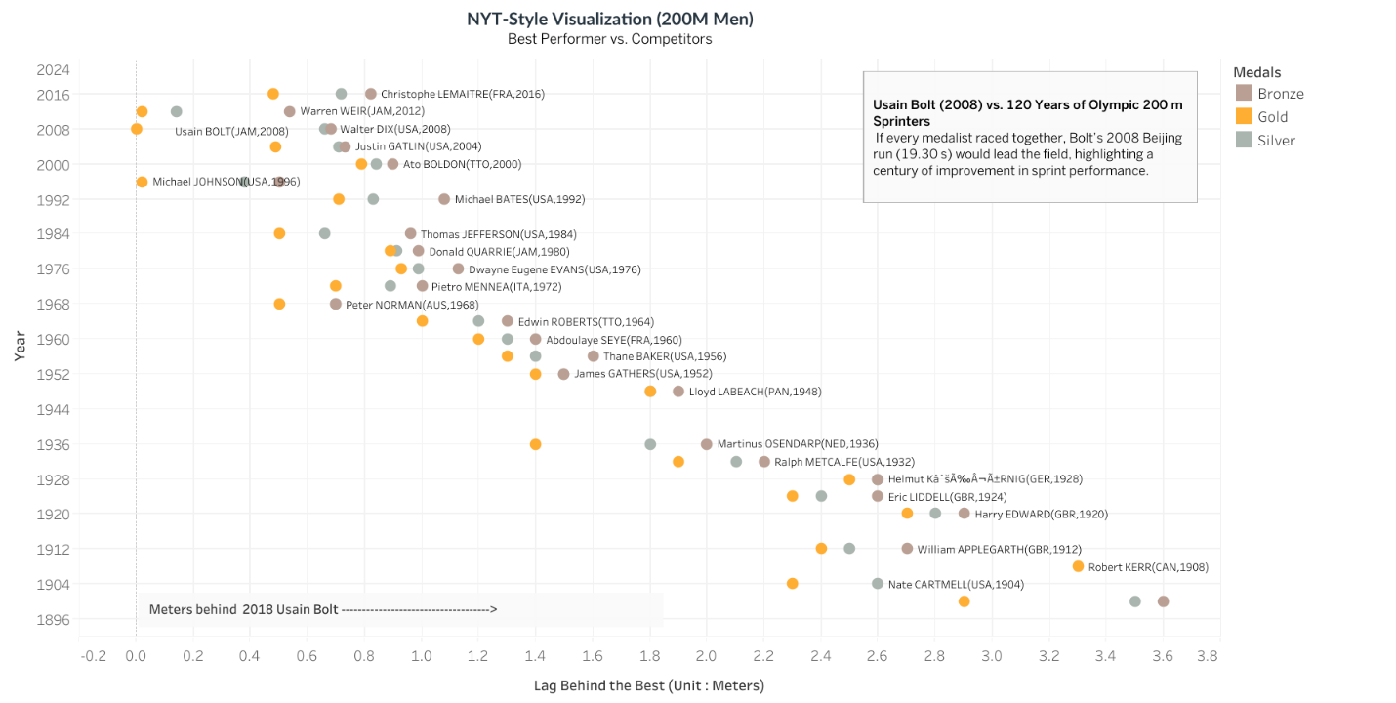

Interpretation:
- Usain Bolt’s 2008 Beijing run (19.30s) leads the entire Olympic history, outperforming earlier champions by over 2.5 meters.
- Performance times have improved from almost22s in 1908 to below 20s post-2000, reflecting a almost9% speed gain over a century.
- Only a few athletes ,notably Michael Johnson (1996) and Yohan Blake (2012) ,came within 0.2–0.3 seconds of Bolt, underscoring his unmatched dominance in sprinting history.

Part 2: More Complex Charts
1. Olympic Dataset Extensions
Chart A: Create a line chart
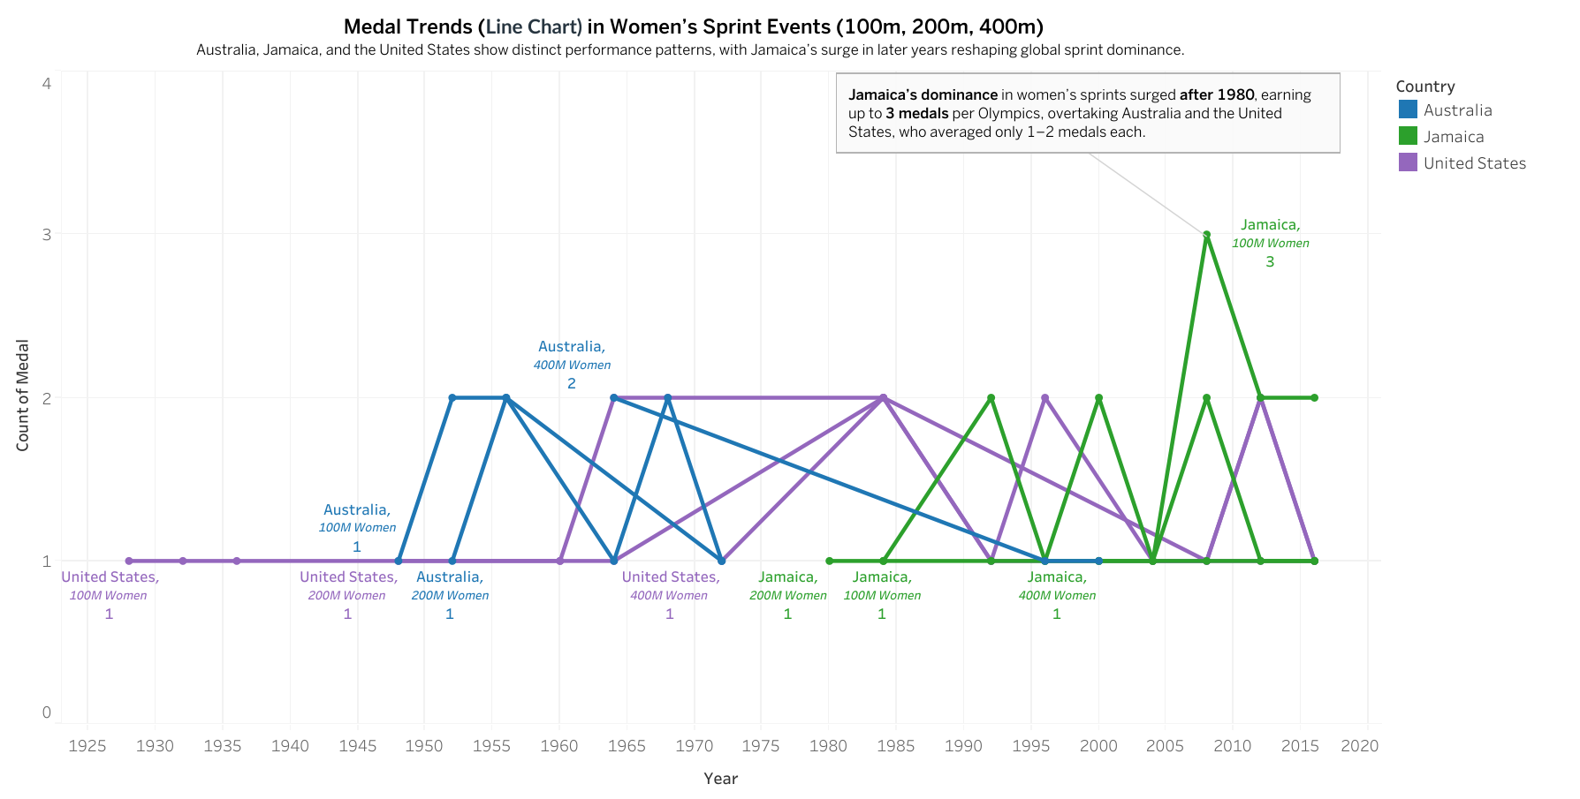
Interpretation:
- Jamaica’s dominance in women’s sprint events surged after 1980, capturing up to 3 medals per Olympics, compared to Australia and the United States, which averaged only 1–2 medals each.
- Between 2008 and 2016, Jamaica maintained its lead, contributing to more than 40% of total medals in the 100m–400m women’s events, reshaping global sprint leadership.
- Earlier decades (1930–1970) were led mainly by Australia and the U.S., highlighting the shift of sprint excellence toward the Caribbean nations in the modern era.

Chart B: Bump Chart
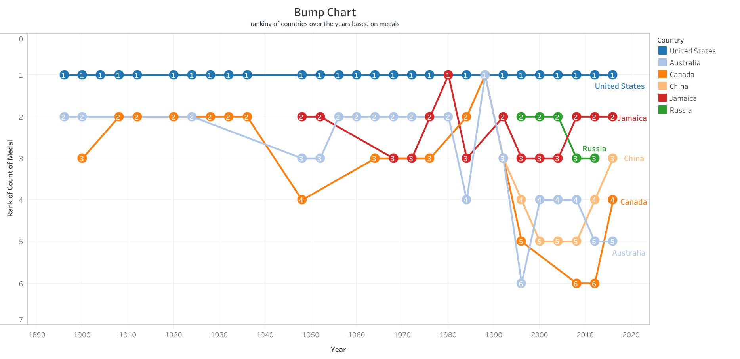
Interpretation:
- The United States has dominated consistently, holding the #1 rank in every Olympic year with the highest cumulative medal count.
- Jamaica and Russia frequently alternated between ranks 2 and 3 after 1980, together contributing to nearly 30–35% of total sprint medals.
- Meanwhile, China, Canada, and Australia fluctuated between ranks 3–6, showing competitive but less stable performances, each securing around 10–15% of total medals in their peak years.
2. Our World in Data – Visualization Assignment
Task A - Download the dataset and create a connected scatterplot
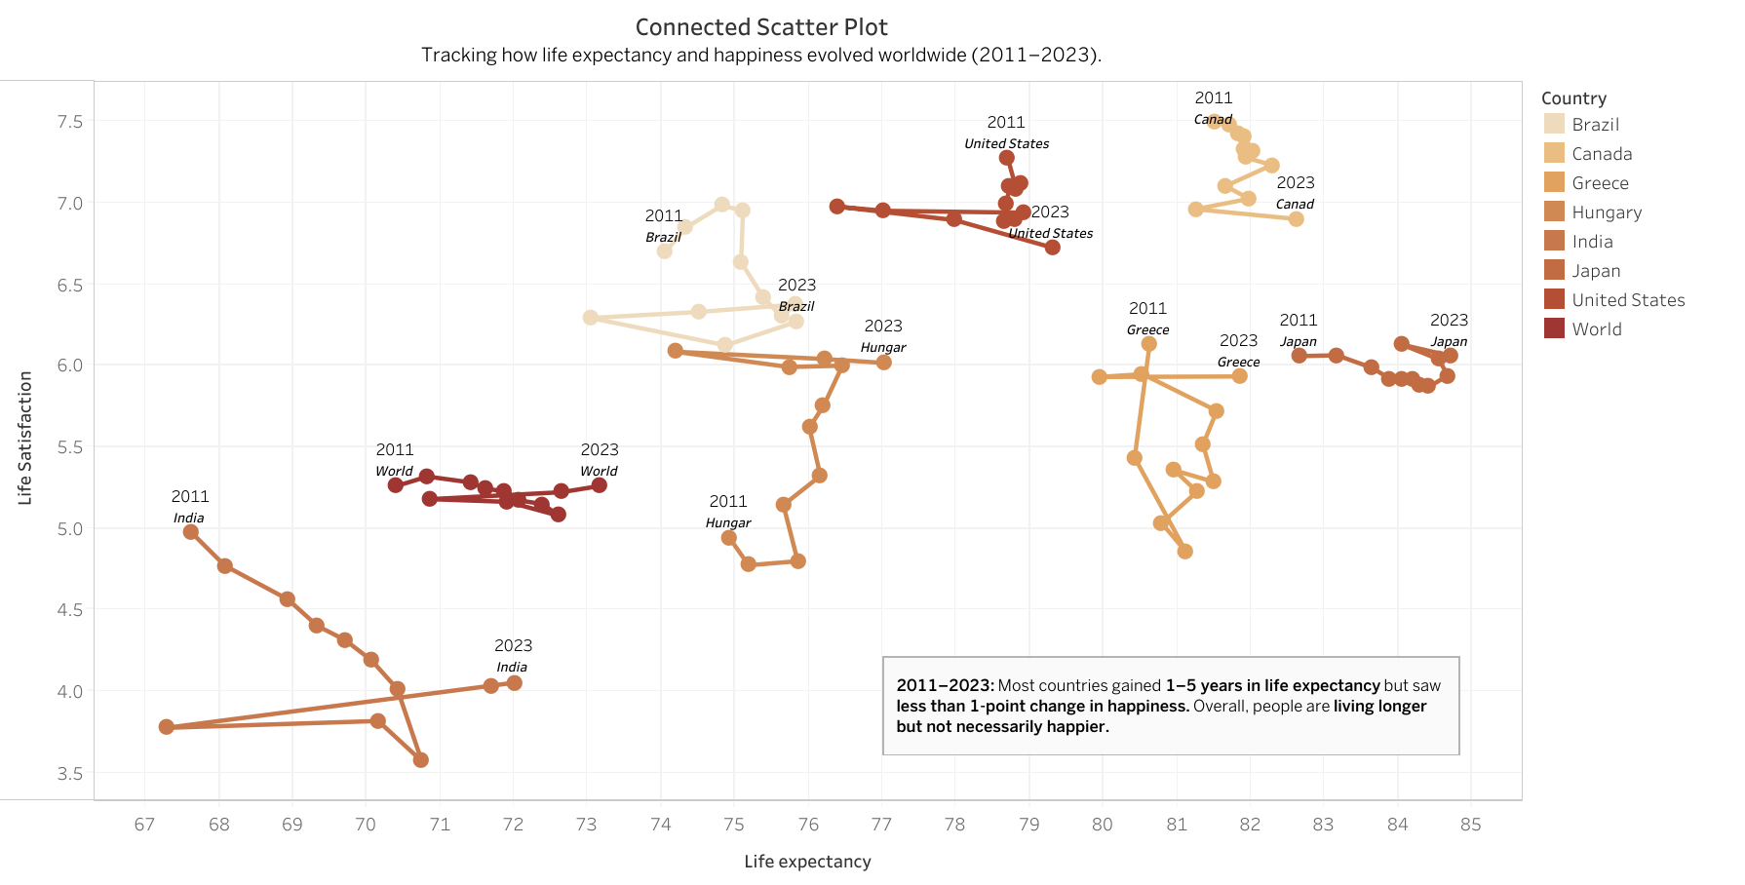

Task B - Insights from the Connected Scatter Plot (2011 – 2023)
This connected scatter plot compares Life Expectancy (in years) and Life Satisfaction (0–10 scale) for selected countries between 2011 and 2023.
Each line shows how a country’s well-being has changed over time. Movement to the right means people live longer; movement up means people feel happier.
India
- Life Expectancy: approximately 67 to 72 years (+5)
- Life Satisfaction: approximately 5.0 to 4.0 (–1.0)
There is a clear decline in life satisfaction from 2011 to 2023, even as life expectancy increases slightly; people live longer but feel less satisfied.
United States
- Life Expectancy: approximately 79 to 77 years (–2)
- Life Satisfaction: approximately 7.0 to 6.8 (–0.2)
Almost flat path with a slight downward tilt, showing stable longevity but a small drop in happiness, possibly due to social or economic stress.
Japan
- Life Expectancy: approximately 83 to 85 years (+2)
- Life Satisfaction: approximately 6.1 to 6.3 (+0.2)
Maintains one of the highest life expectancies, but only small improvements in happiness; longevity doesn’t guarantee higher life satisfaction.
Greece
- Life Expectancy: approximately 80 to 81 years (+1)
- Life Satisfaction: approximately 6.6 to 5.8 to 6.2 (fluctuating ±0.8)
Noticeable up-and-down movement, reflecting economic instability during the Eurozone crisis and its impact on well-being.
Hungary
- Life Expectancy: approximately 75 to 77 years (+2)
- Life Satisfaction: approximately 4.8 to 6.0 (+1.2)
Moves upward and right, showing strong progress in both life expectancy and happiness, a positive well-being trend.
Brazil and Canada
- Brazil: Life Expectancy approximately 73 to 75 (+2); Life Satisfaction approximately 6.8 to 6.2 (–0.6).
- Canada: Life Expectancy approximately 82 to 83 (+1); Life Satisfaction approximately 7.1 to 7.0 (–0.1).
Generally stable patterns, with moderate improvements in health and small or no change in happiness.
World Average
- Life Expectancy: approximately 71.5 to 73 years (+1.5)
- Life Satisfaction: approximately 5.3 to 5.4 (+0.1)
Slight gain in life expectancy but nearly flat happiness, highlighting that globally, people are living longer but not necessarily happier.
Overall Insights
- Most countries gained 1–5 years of life expectancy between 2011 and 2023.
- Happiness (life satisfaction) changed by less than ±1 point for most, showing that well-being progress is uneven.
- Up-and-right movement = better health + higher happiness (e.g., Hungary).
- Downward or flat movement = healthier but not happier lives (e.g., India, U.S.).
- Globally, longevity improvements outpaced emotional well-being gains.
Use filters on the right to explore additional countries and year ranges to see how different nations’ well-being trajectories evolve over time.
Use of AI:
AI tools were used to refine visualization insights, generate annotation phrasing, and validate quantitative interpretations for accuracy and clarity.
They also assisted in summarizing performance trends, identifying key milestones (e.g., Bolt’s 2008 record), and improving the overall storytelling quality of the visuals.

